Matt Bogacz

IT 170

3/2/2020

Program Assignment 2

Part 1 Read me – In part 1 I created an empty list and a for loop that generated numbers from 1-100, then I appended the numbers in the for loop into the empty list so that it contained 100 values. I then took the length of myList and stored it as a variable, divided the numbers in the range by the length of the list and printed the average number.

Screenshot -

Part 2 Read me – First I prompted the user to define the amount of numbers he would like to enter and an empty list. Then I created a for loop that ran the amount of times that the user inputted which prompted the user to enter a number, which would then be appended into a list and added to a variable named “average”. After the loop ended, I took the variable “average” and divided it by the number the user entered which gave the actual average. Then I printed the variable

Screenshot –

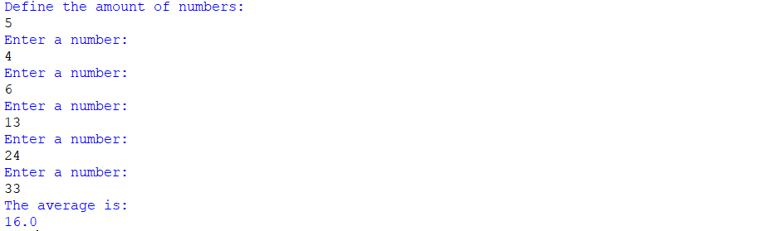

Part 3 Read me – I started by creating the two required dictionaries. Both dictionaries contained all the students. The first one studentName contained all the test scores and the second one had a default value of 0. I then created a for loop that ran through the studentName dictionary and another loop in that loop that ran through the test scores of each student and added them to a variable named number. After the second loop stopped running the first loop continued and divided the scores by 5 and which gave the test average. Then I assigned the variable to the list. After that I created another variable named “highest” which I set to 0. In the same loop I checked if the value in highest was less than the number in the loop, if it was it replaced the number in “highest”. At the end I added a print statement that printed the highest value.

Screenshot –



Part 4 Read me – In this part I reuse an existing loop that determined the average and highest test score in part 3. I add in an if statement that assigns a letter to the corresponding test score and adds it to a new Dictionary (named studentLetter) with the according student. After this, I created a for loop near the end of the program that runs through the studentLetter dictionary and use string concatenation to print the appropriate student and letter.

Screenshot –

